The final graphs of my country: Sacramento County, California

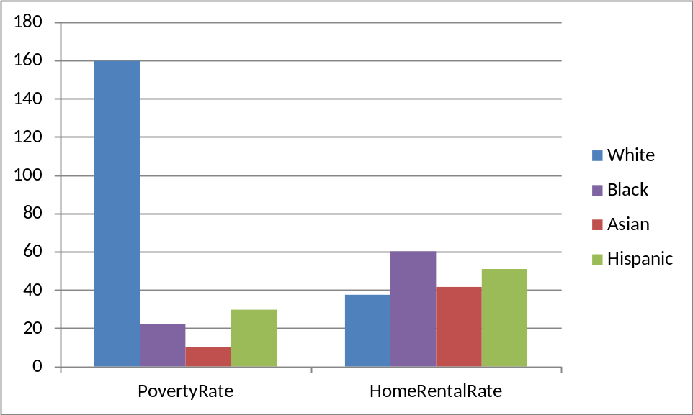

Based on this graph we see that the poverty of Asian is highest and the White is lowest. But, the house rental rate is not much different, all four races have nearly the same house rental rate

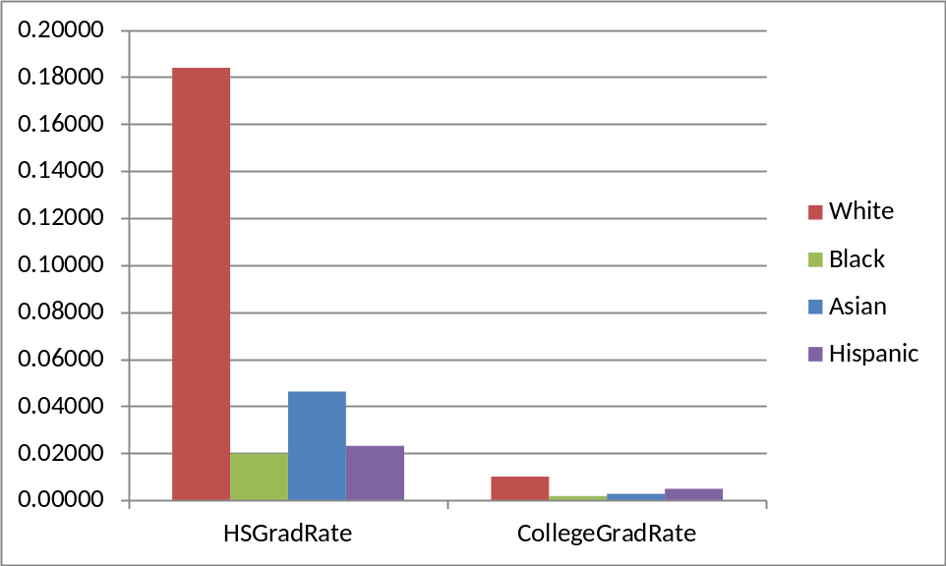

Based on the graph we see that the college rate and the graduate rate are much different. This indicates that all four races focus on the higher education. For both college and the graduate, the White has the highest rate and the rest three races have nearly the same rate of education

